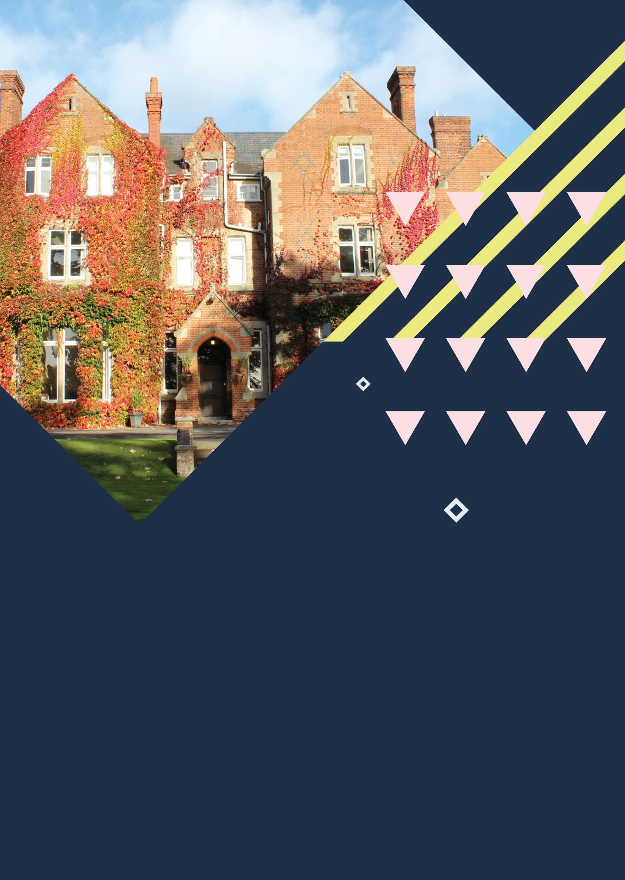


Reading
,
Queen Anne’s School

Centre Handbook

2026

Contents

Contents 2
Summary 3
The Centre 4
Location 5
Airport Transfers: 5
Local Amenities 7
Accommodation 9
Room Allocation 9
Housekeeping 9
Key Loss 9
Deposits 9
Meals 10
Meal times 10
Queen Anne’s, Reading - Sample Menu 11
Technology 12
Security 12
Safety 12
Teaching 13
Placement tests Error! Bookmark not defined.
Programme Error! Bookmark not defined.
A typical day for students 15
Reading, Queen Anne’s School Programme - Summer 2026 16
Facilities 17
Evening entertainment 17

Thank you very much for your interest in our centre at Queen Anne’s School. We hope you find everything you need in the following pages but if you have any questions or specific requests then please get in touch with us at Head Office on 0044 1244 577995.
The contents of this handbook are updated regularly. The latest version will be sent before your arrival.
We look forward to a successful summer 2026 at Queen Anne’s School.

Summary


Boarding School

Swimming Pool

Intensive English

Performing Arts
Short Transfers

The Centre

Queen Anne’s School has a history which dates back to 1698. It is situated in a closed campus with 35 acres of extensive landscaped grounds, just north of the River Thames. The grounds combine traditional Victorian architecture with new and contemporary buildings to provide cutting-edge facilities, all of which are just a one and a half mile walk from the centre of Reading

The school is a closed site, with CCTV coverage of most areas. There are duty officers on site 24 hours a day. Over-night security guards patrol the school grounds.

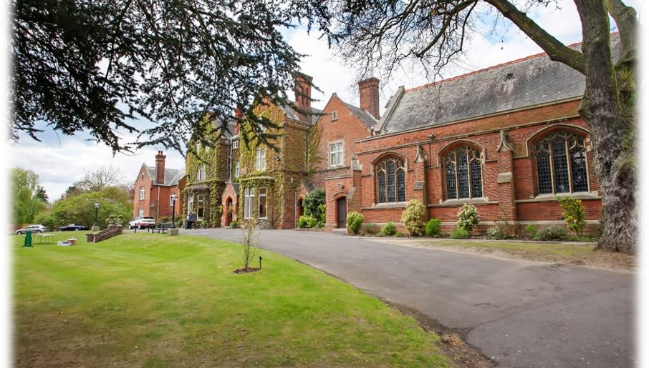

Location

QUEEN ANNE’S SCHOOL, 6 HENLEY ROAD, READING, RG4 6DX

Telephone Number – +44 (0)118 9187300

Population – 318,014

Queen Anne’s School, Caversham is located approximately 1 mile from Reading town centre.
Reading, the county town of Royal Berkshire, is a place of surprising contrasts. It is a large town on the Thames and Kennet rivers in southern England which has existed since around 800 AD and blends the very best of old and new - from coaching inns and Victorian gothic public buildings, to imposing modern offices. It is a vibrant town with many shops and riverside restaurants and plenty of history to be explored.

Airport Transfers:
London Gatwick: 1 hour 15 minutes London Heathrow: 40 minutes London Stansted: 1 hours 35 minutes
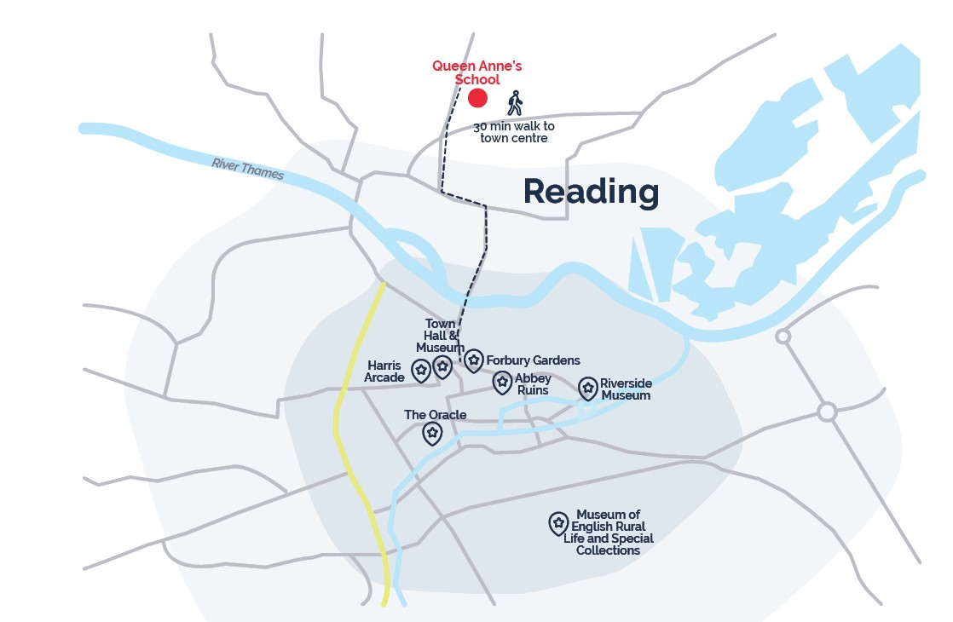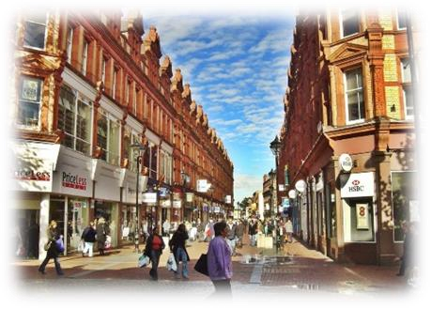
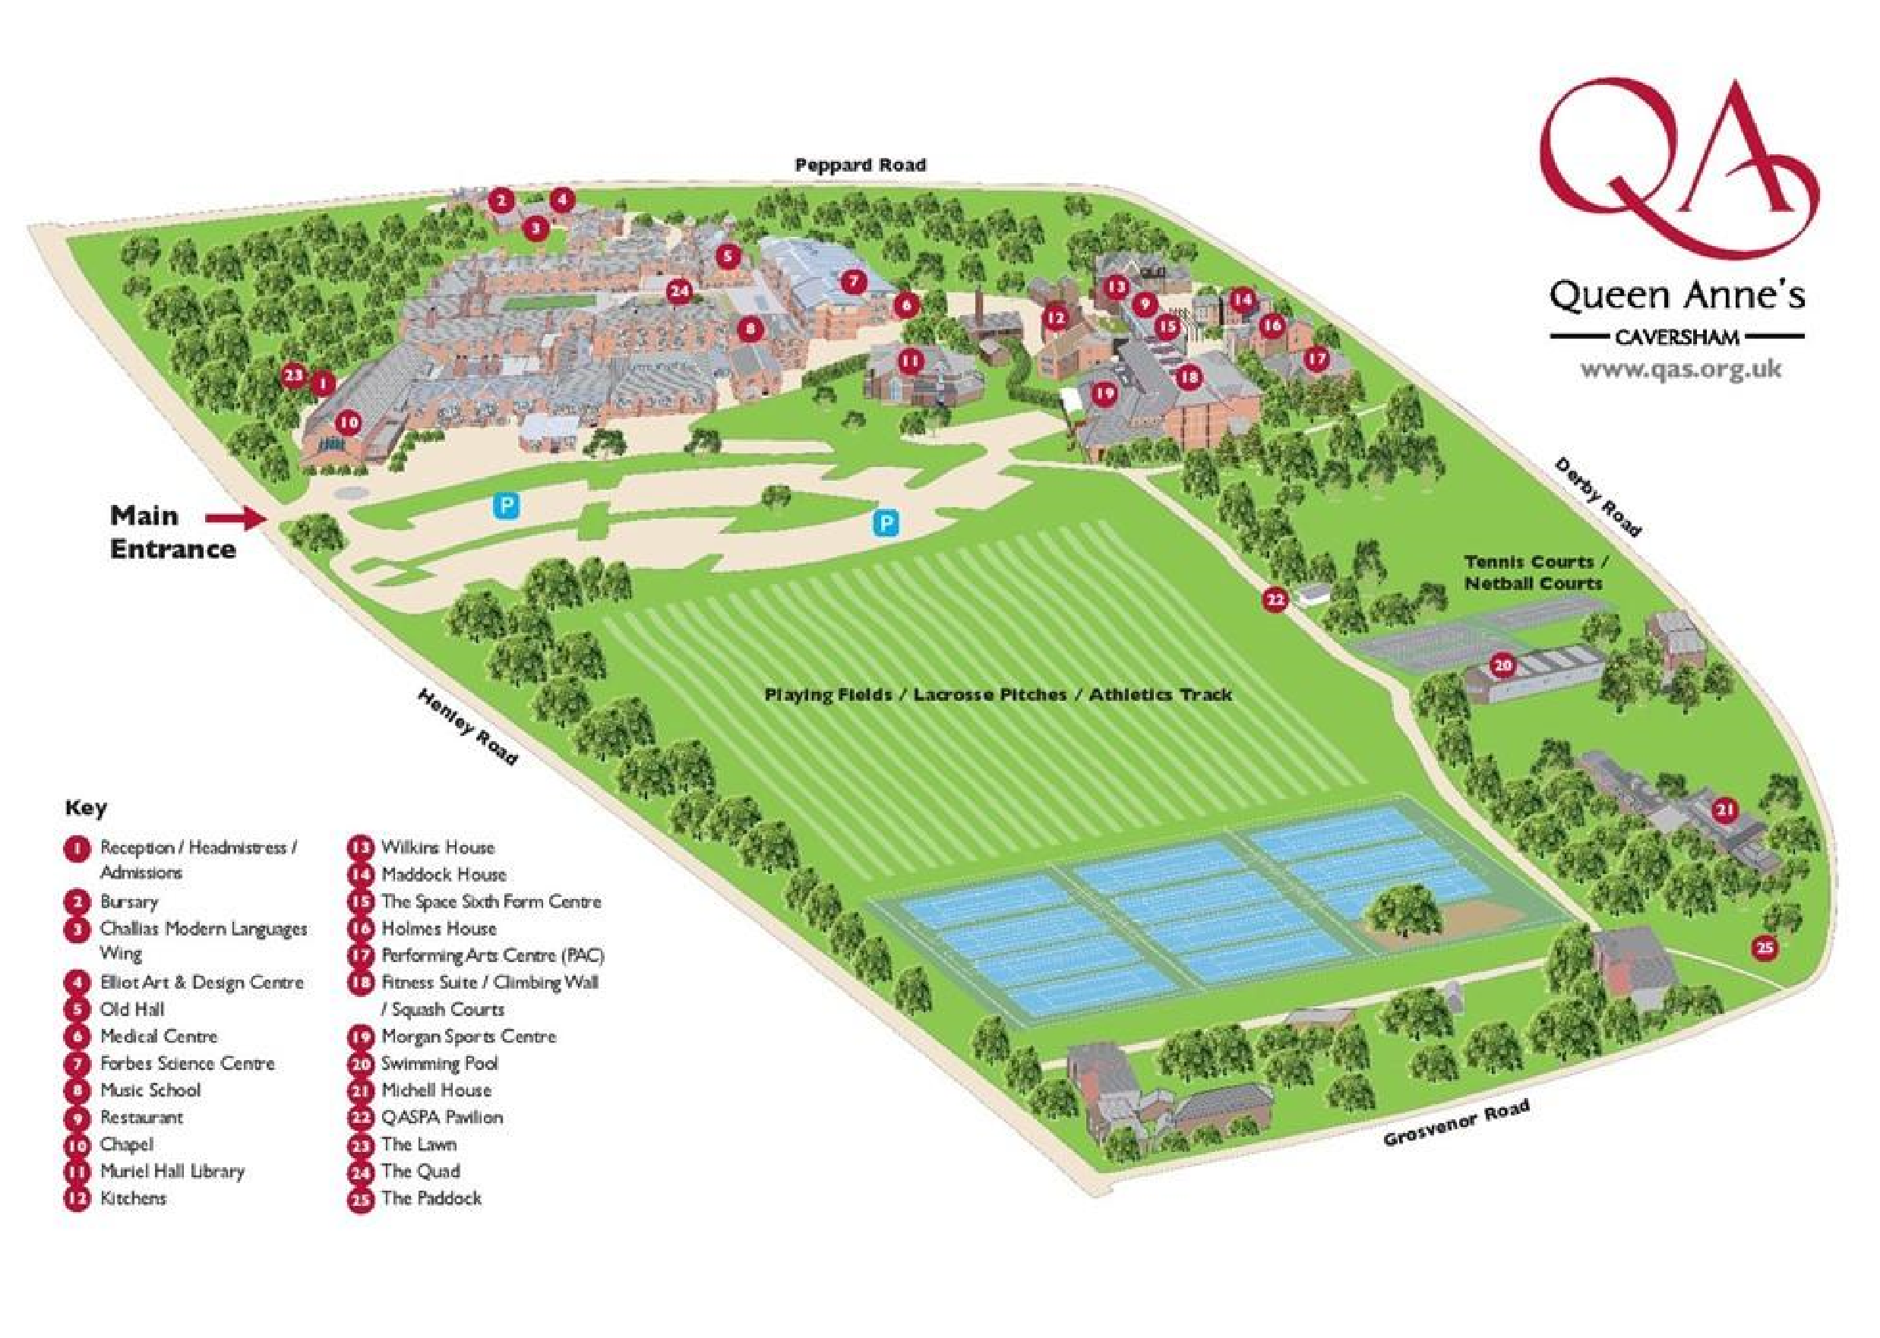

Local Amenities

Post Office
The Co-operative Food
Address: 124 Henley Rd, Caversham RG4 6DH (0.3 miles / 5 minutes’ walk)

Supermarket
The Co-operative Food
Address: 124 Henley Rd, Caversham RG4 6DH (0.3 miles / 5 minutes’ walk)

ATM
The Co-operative Food
Address: 124 Henley Rd, Caversham RG4 6DH (0.3 miles / 5 minutes’ walk)

Chemist
Markand Pharmacy
Address: 122 Henley Rd, Caversham RG4 6DH (0.3 miles / 5 minutes’ walk)

Hospital
Royal Berkshire Hospital
Address: Craven Rd, Reading, RG1 5AN (2.1 miles / 10 Minutes’ drive)

Doctors
Balmore Park Surgery
Address: 59a Hemdean Road, Caversham,RG4 7SS (0.5 miles / 9 Minutes’ walk)
*N.B. If a student is ill and requires a doctor, a group leader and a UKLC staff member will take the student to the NHS medical centre at Royal Berkshire Hospital. The student will be required to fill out a temporary patient form and will be seen on the same day.*

Dentist
Prospect Street Dental Practice
Address: 19 Prospect St, Reading, RG4 8JB (0.4 miles / 7 minutes’ walk)

Bus Stops
Turn left out of the school and they are approx. 0.3 miles/ 5 minutes’ walk away. There are frequent busses that run to Reading Town Centre and surrounding suburbs.

Train Stations
Reading Railway Station
Address: Station Hill, Reading RG1 1LZ (1.2 miles / 25 minutes’ walk or 10 minutes by car)
Regular trains to London Paddington, Oxford and Bournemouth.

Taxi Companies
Thames Valley Taxis: 0118 948 4848
500 cars Ltd: 0118 959 9999
Haightons: 01270 624574

Coffee Shops
Nathan’s Nibbles
A fun and friendly local café in Caversham, Reading
Address: 4 Prospect Street, Reading, RG4 8JG
Walking distance from Queen Anne’s School: 0.3 miles (6 minutes’ walk)

The Bite Cafe
Serving hot drinks, traditional and veggie breakfasts, meals, and snacks.
Address: 6 cavendish road, Reading RG4 8XU
Walking distance from Queen Anne’s School: 1 mile (18 minutes’ walk)

Restaurants
The Last Crumb
Hip pub offering an American-style menu of burgers & pizza, plus beer & cocktails.
Address: 76 Prospect Street, Caversham, Reading, RG4 8JN
Walking distance from Queen Anne’s School: 0.2 miles (2 minutes’ walk)

Quattro
Italian menu favourites amid a modern setting of stripped-flooring and heavy, pale-wood furniture.
Address: 14 Prospect Street, Reading, RG4 8JG
Walking distance from Queen Anne’s School: 0.4 miles (8 minutes’ walk)

Accommodation

The school has 4 residential houses all with single and twin (some of which are ensuite) or multi-bedded rooms with shared shower and toilet facilities. Each house has its own common room and kitchen. The houses are called Michell, Holmes, Maddock and Wilkins and have key coded access.

Mitchell house is made up of single and twin rooms with shared bathroom facilities and a ratio of 1:4. There is 1 kitchen and 1 common room in this house.

Holmes house is made up of single en-suite and twin en-suite rooms. There is 1 kitchen and 1 common room in this house.

Wilkins house is made up of single rooms, twin rooms, triple rooms, and quads with shared bathroom facilities. These standard rooms have a sink basin located in each room. There is 1 kitchen and 1 common room in this house.

Maddock house is made up of single rooms, twin rooms and triple rooms with shared bathroom facilities and a ratio of 1:4. These standard rooms have a sink basin located in each room. There is 1 kitchen and 1 common room in this house.

Room Allocation
We divide the students up according to their age, gender and group where possible. We take into consideration any specific requests, e.g. friends who want to share. Group leaders will generally stay in the same house as their students. Room allocation is normally done on arrival. If you would like any further information about this, please contact us.

Housekeeping
Bedding is changed once a week. Towels are not provided. Bedrooms, bathrooms, and public areas are cleaned 6 times a week. There are washing machines and tumble dry facilities located in each house that are free to use but students must provide their own washing powder.

Key Loss
This centre does not provide keys. There are key codes for each accommodation.

Deposits
We will ask each student for a deposit of €25/£25 on arrival. We will check their rooms before they arrive and before they leave and return the money if everything is in order. If there is damage to the houses and nobody admits fault, we will ask everyone in the house to share the cost.

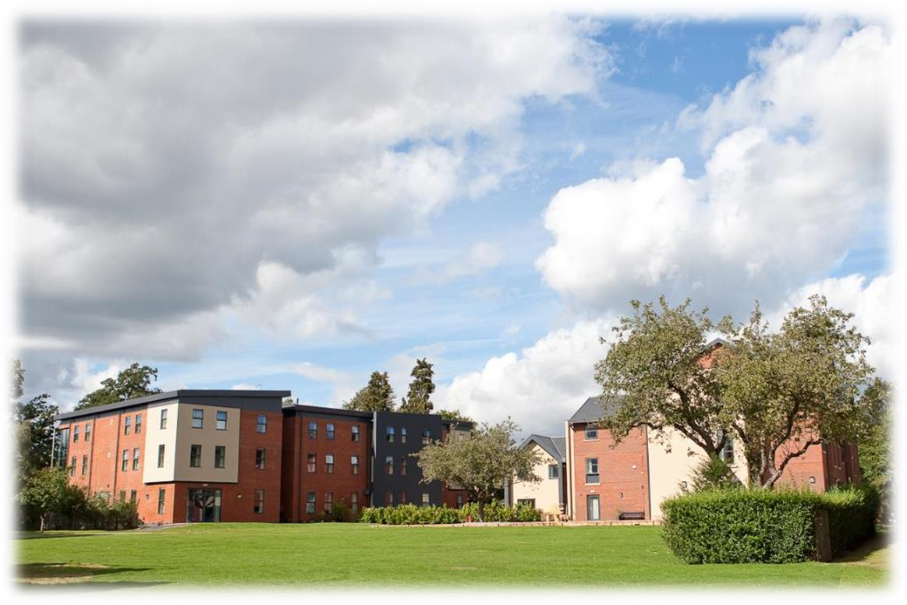

Meals

When the students are on campus, they will eat their meals in the dining hall on site. When they are out on full day excursions, they will be provided with packed lunches.
Cooked breakfast is supplied 3 times a week and the others are continental breakfast.

Meal times*
Breakfast: 08:00 – 08:45
Lunch: 12:30- 13:30
Dinner: 18:30 - 19:00

If we are aware in advance, we can advise the catering staff of any dietary requirements or allergies and the canteen staff can cater to these.

*Mealtimes are subject to change

Queen Anne’s, Reading - Sample Menu

Monday Tuesday Wednesday Thursday Friday Saturday Sunday

Breakfast | Fried Egg,  Croissants, Pain au chocolate,  Toast, Cereal,  Yoghurt  Butter and Fruit | Boiled egg,  Croissants, Pain au chocolate,  Toast, Cereal,  Yoghurt  Butter and Fruit | Fried Egg,  Croissants, Pain au chocolate,  Toast, Cereal,  Yoghurt  Butter and Fruit | Full English  Breakfast  Croissants,  Toast, Cereal,  Yoghurt  Butter and Fruit | Boiled egg,  Croissants, Pain au chocolate,  Toast, Cereal,  Yoghurt  Butter and Fruit | Full English  Breakfast  Croissants,  Toast, Cereal,  Yoghurt  Butter and Fruit | Full English  Breakfast  Croissants,  Toast, Cereal,  Yoghurt  Butter and Fruit
Lunch  *(V)  Vegetarian option available | Dish of the day  Sweet and sour chicken  Vegetarian option  Chargrilled Polenta and roasted veg  Sides  Vegetables of the day  A selection of freshly  prepared salads  Fresh  homemade bread | Dish of the day Hot Wraps  Crispy Chicken  Vegetarian option  Vegetable and  Halloumi Wrap  Sides  Vegetables of the day  A selection of freshly  prepared salad  Fresh  homemade bread | Dish of the day Selection of  meat pizzas  Vegetarian option  Vegetable Pizza  Sides  Vegetables of the day  A selection of freshly  prepared salad  Fresh  homemade bread | Dish of the day  Tandoori  Chicken Leg  Vegetarian option  Mushroom  Pasta Bake  Sides  Vegetables of the day  A selection of freshly  prepared salad  Fresh  homemade bread | Dish of the day  Crispy battered fish  Vegetarian option  Spinach and  Ricotta gnocchi  Sides  Vegetables of the day  A selection of freshly  prepared salad  Fresh  homemade bread | PACKED LUNCH  FOR FULL DAY  EXCURSION | Dish of the day  Pilled chicken  Vegetarian option  Roasted  Vegetables  Sides  Vegetables of the day  A selection of freshly  prepared salad  Fresh  Homemade bread
Dinner  *(V) Vegetarian option available | Dish of the day  Moussaka  Vegetarian option  Vegetarian  Moussaka  Sides  Vegetables of the day  A selection of freshly  prepared salad  Fresh  homemade bread | Dish of the day  Chicken Leg, red onion and olive  Vegetarian option Butternut squash &  spinach Frittata  Sides  Vegetables of the day  A selection of freshly  prepared salad  Fresh  homemade bread | Dish of the day  Herb Turkey  Schnitzel  Vegetarian option  Gnocchi alla  Romana  Sides  Vegetables of the day  A selection of freshly  prepared salad  Fresh  homemade bread | Dish of the day  Filled jacket potato  Vegetarian option  Filled jacket potato  Sides  Vegetables of the day  A selection of freshly  prepared salad  Fresh  homemade bread | Dish of the day  Chicken Fajita wraps  Vegetarian option  Vegetable fajita wraps  Sides  Vegetables of the day  A selection of freshly  prepared salad  Fresh  homemade bread | Dish of the day  Beef / Chicken burger  Vegetarian option  Bean burger  Sides  Vegetables of the day  A selection of freshly  prepared salad  Fresh homemade bread | Dish of the day  Chicken, leek and mushroom pie  Vegetarian option  Vegetable and garlic stuffed mushrooms  Sides  Vegetables of the day  A selection of freshly  prepared salad  Fresh homemade bread
Pudding | Whole fruits | Whole fruits | Whole fruits | Whole fruits | Whole fruits | Chocolate Cake | Whole fruits

Technology

Wi-Fi is available campus wide and is password protected. We normally only give this password out to Group Leaders / adults. Being a private boarding school, the internet access is firewalled as per the boarding school regulations.
It is at the Group Leader’s discretion whether they give these details to their students.
Wi-fi will be switched off between 00:00 and 07:00.

There are no public phones on site. The nearest is located on Church Street opposite the Alto Lounge restaurant approximately 0.8 miles / 8minutes’ walk from the school.

Security

There is CCTV coverage on campus and 24/7 duty security/wardens. The main gate is locked at midnight.

Emergency contacts: Each student will be given a wristband when they arrive, and this will have the following emergency telephone number printed on it: 00 44 1244 567695. If you need to contact the centre in the event of an emergency please call this number and follow the options for the relevant centre, this will then put you through to the person on duty.

Certain basic guidelines are common to all centres and students. Students should:
- Never walk away alone!
- Never leave the residence without permission in the evening!
- Always make sure they have understood when and where the meeting point is whilst out on excursions!
- Always wear their identification lanyard and their UKLC wristband! *
*students found not wearing their lanyard or wristband will be fined £1

Safety

- Remember that there is a 24-hour emergency telephone number on the wristband (0044 1244 567695) and that the number for the emergency services (Ambulance/Police/Fire) in England is 999, or the single emergency number for the EU including the UK is 112 or you can call 101 to report a crime where you do not need an emergency response.
- The police are there to help and protect and can be asked for assistance!
- Never respond to someone if you feel threatened, simply walk away!
- Always give your money to the UKLC management team to put in the safe and never to carry large amounts of cash around!
- Be careful crossing the road. Remember that in the UK we drive on the left!
- If you are ill or need a doctor, tell a member of UKLC staff immediately!
- Keep all windows closed when not in your bedrooms!

Insurance and valuables
Although all houses will be accessed via codes, rooms cannot be locked and it is suggested that students try to avoid bringing very expensive items with them. If they are bringing valuables with them, it essential that they have sufficient insurance to cover any loss of damage as neither the centre nor the company can be held responsible if anything goes missing. The Centre Manager will have access to a safe if it is required.

Teaching

We know how important it is for each individual student to find their own path in language learning. We use a wide range of methods to engage and stimulate our students. This is why we have created a curriculum based on the students’ age, level and needs, structured into four different programmes:
FUN (ages 8-10)
Engaging lessons that offer a wide range of materials and activities specific for our young learners, making games into lessons and lessons into games. Available in levels A1-B1.

CONNECTION (ages 10-13)
Dynamic lessons covering a variety of topics and media, designed to engage students using tools native to the fast-paced world they are growing up in. Available in levels A1-C1.

ACTION (ages 13-16)
Lessons tailored for learners stepping into their teenage years. This programme focuses on activating students’ knowledge and competencies to balance developing a personal voice while contributing effectively to a team. Available in levels A1-C1.

PURPOSE (ages 16-18)

Lessons tailored for our students approaching adulthood, designed to kickstart their lives not only as maturing youths but also as forward-thinking global citizens. Available in levels A1-C2.

The Connection, Action, and Purpose programmes consist of three different lessons a day:

FOCUS ON LANGUAGE

These lessons aim to empower our students’ linguistic awareness and capabilities by working on all language skills (reading, writing, listening, speaking) and systems (grammar, phonology, lexis, discourse), as well as using materials relevant to exam preparation (KET, PET, FCE, CAE, TOEFL, IELTS, GESE).

FOCUS ON LEADERSHIP

This programme is designed to equip students with essential 21st-century skills, focusing on leadership development, communication and teamwork. Students build the confidence and competencies needed to grow into empowered young adults.

FOCUS ON CULTURE
These lessons combine CLIL and British culture, allowing students to use English to explore a range of disciplines, including art, literature, natural sciences, as well as the history and geography of the UK.

Placement tests
We offer classes at four levels, from elementary to advanced. Students take a placement test on their first day of classes to ensure they are placed at the correct level.

Once the tests have been marked, students won’t be told their score unless they specifically ask for it but will be placed into a class based on these results.

If students are not happy with their level, they can speak with the Course Director who will decide if it is necessary for the student to change levels.

We always try to split groups into different classes to mix nationalities, but this does depend on their levels and the numbers of students that we have on site.

We will provide all course materials including a journal and a pen.

Students are taught in class sizes up to 16.

Programme

All UKLC summer programmes include:

- 15 hours of English lessons
- Full board accommodation in residence
- Full programme of excursions, activities and evening entertainment
- 1 free leader for 15 students
- Placement test on arrival and End of Course Certificate

These are summaries of UKLC English Plus programmes** for Summer 2026 at Clifton College, Bristol:

English Plus Multi-Activity
The “typical” summer programme consisting of a wide variety of activities and sports. Sessions are structured and are coached by specialist staff. Sessions can include tennis, basketball, volleyball, swimming, photography workshops, dance, football, and drama etc. Students are moved through two or three activities on rotation in each session.

English Plus Performing Arts*
During these sessions, students passionate about dancing, acting, or singing will immerse themselves in hands-on training designed to unleash their creative potential on any kind of stage. They will not only develop their talents but also experience the thrill of live performance, collaboration, and artistic expression.

English Plus Intensive English & Community Building*
Additional English lessons for those who really want to maximise their language learning during their stay in the UK. Based on UKLC's integral community-building approach, these additional lessons aim to help students develop an active role in the school as a thriving community, with its challenges, complexities and opportunity for collective growth. The Community Building lessons focus on how to empower students to work together to find possible solutions to these needs and issues by communicating with people on campus. Students create these projects that they are responsible for in order to improve these issues on campus.

*Students aged between 11 and 17 who are enrolled on Multi-Activity or English Plus courses will be divided by age for activities where numbers allow. Students can choose whether to enrol on the Multi-Activity or an English Plus course.
All students aged between 8 and 10 will be automatically enrolled on the multi activity programme.

**These programmes vary at each centre. A minimum of 10 students applies to each programme and each student will be asked to select a 1st and 2nd option before arrival which they will join for the duration for their stay. Students who do not choose in advance will join the standard English Plus Multi-Activity.

A typical day for students

08:00 – 09:00 | Breakfast
09:00 – 10:00 | Lesson 1
10:00 – 10:15 | Break
10:15 – 11:15 | Lesson 2
11:15 – 11:30 | Break
11:30 – 12:30 | Lesson 3
12:30 – 13:30 | Lunch
14:00 – 17:30 | Afternoon Activities
18:30 – 19:30 | Dinner
20:00 – 22:00 | Evening Activities
22:00 | Bedtime

This centre may run on a ‘zig-zag’, meaning the order of lessons and multi-option activities/excursions will change after a week. See example below.

Reading, Queen Anne’s School Programme - Summer 2026

Week 1 |  | Morning | Afternoon | Evening
 | Monday | English Test | Multi-Activity or  Chosen Programme | Murder Mystery
 | Tuesday | Lessons | Caversham Orientation | Casino Night or  Conversation Club
 | Wednesday | Lessons | Vlogging Workshop or  Chosen Programme | Trashion Show
 | Thursday | London -  Buckingham Palace, Downing Street, Houses of Parliament & London Eye |  | Disco
 | Friday | Lessons | Multi-Activity or  Chosen Programme | Red vs Blue
 | Saturday | Lessons | Free Time, Activities,  or Optional Excursion | Karaoke
 | Sunday | Oxford with Oxford University Alumni Walking Tour |  | Film Night
W  eek 2 | Monday | Multi-activity or  Chosen Programme | Lessons | Karaoke or Conversation Club
 | Tuesday | Reading with Reading Museum | Lessons | Paparazzi
 | Wednesday | Vlogging Workshop or Chosen Programme | Lessons | Mini Olympics
 | Thursday | Windsor with Windsor Lessons  Castle |  | Oscars
 | Friday | Multi-activity or Chosen Lessons  Programme |  | Talent Show
 | Saturday | London with Greenwich, National Maritime Museum & Cutty Sark & the Royal Observatory |  | Leaving Disco
 | Sunday | Departures

Please note: This is a sample programme and may be subject to change.

Facilities

Sports facilities on site
- Sports hall
- Dance & Drama Studios
- Indoor swimming Pool
- Tennis courts
- Grass football pitch

Sports available at this centre can include - football, Badminton, basketball, rounders, volleyball, cricket & tennis.

Evening entertainment
The UK Language Courses staff plan fantastic activities to make sure the students enjoy their evenings. For example: discos, quizzes, fashion shows, blind date, sports tournaments etc. We ask Group Leaders to encourage students to participate as much as possible and to communicate any special ideas or requests from students.

Here are a few brief descriptions of just some of our activities for students to join in on:

Around the World
Consists of a number of different stations based on activities from different countries. One staff member will be placed at each activity station. They will each represent a country and have to create an activity related to that country (for example: New Zealand – The Haka). Students will be divided into groups and given a time for each station. Students will visit each station.

Oscars Night
Involves students watching a number of scenes from selected films. They will have the chance to re-enact a famous selected scene. Creating their own script, which must be in English and costumes (out of various given equipment). Scenes will be shown on a big screen for everyone to watch. Awards will be given by UKLC staff for the best reproduction.

Speed Dating
Enables students from mixed nationalities to socialise and get to know each other whilst improving their spoken English. Students will have a short period of time to have a conversation on their interests, hobbies etc. Once the given time finishes they will move to another student and begin the same process again.

Talent Show
Gives students the opportunity to perform talents such as singing, dancing and acting in front of the whole centre! Sign-up sheets will be available in the centre a few days before the event. There will be judges who will score the performances and give positive feedback to each student who performs on the evening.

We look forward to welcoming you to Queen Anne’s school, Reading, in summer 2026!
